**LAB PROGRAM 1:**

**Develop a Java program that prints all real solutions to the quadratic equation ax2 +bx+c = 0.**

**Read in a, b, c and use the quadratic formula. If the discriminate b^2-4ac is negative, display a message stating that there are no real solutions.**

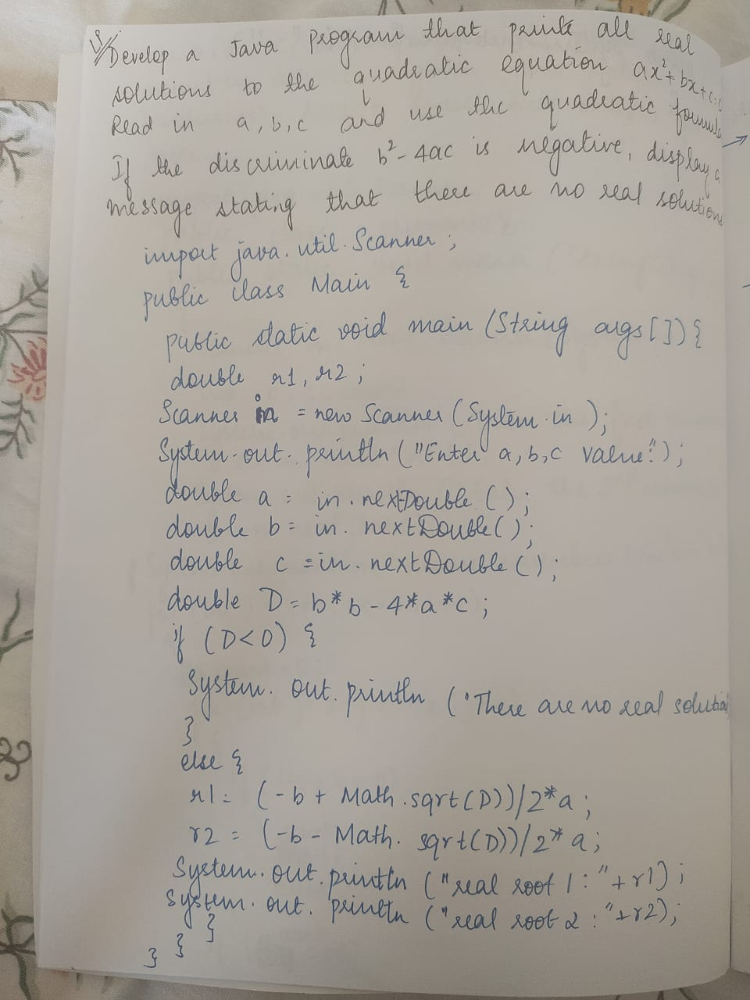

import java.util.Scanner;

public class Main {

public static void main(String args[] ){

double r1,r2;

Scanner in = new Scanner(System.in);

System.out.println("Enter a,b,c value:\t");

double a = in.nextDouble();

double b = in.nextDouble();

double c = in.nextDouble();

double D = b*b-4*a*c;

if(D<0) {

System.out.println("There are no real solutions");

}else {

r1 = (-b+Math.sqrt(D))/2*a;

r2 = (-b-Math.sqrt(D))/2*a;

System.out.println("real root 1: "+r1);

System.out.println("real root 2: "+r2);

}

}

}

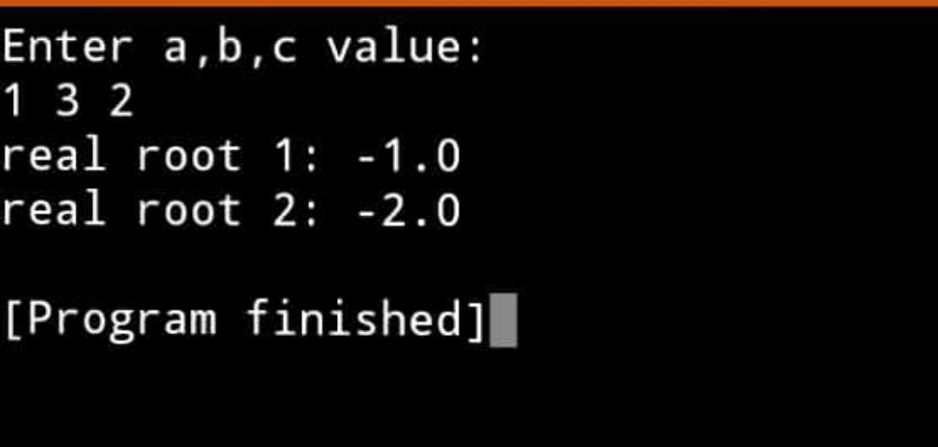

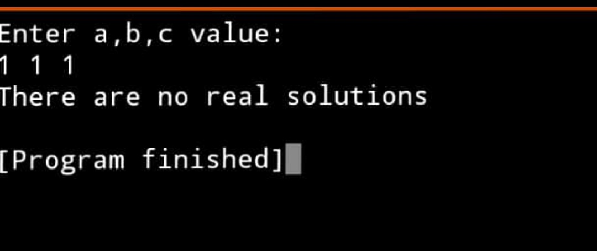

**LAB PROGRAM 2:**

**Develop a Java program to create a class Student with members usn, name, an array**

**credits and an array marks. Include methods to accept and display details and a method to**

**calculate SGPA of a student.**

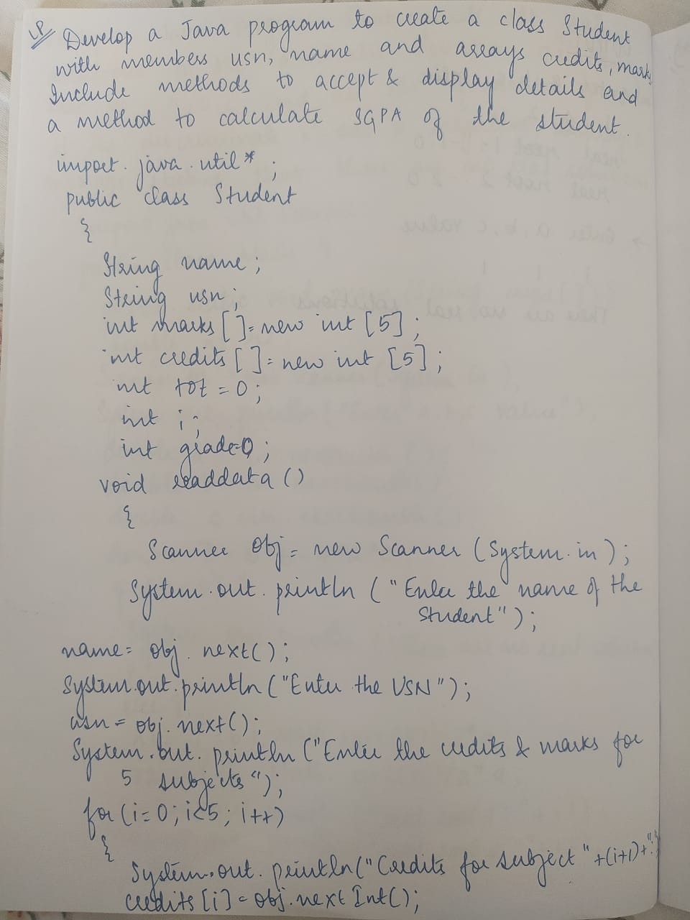

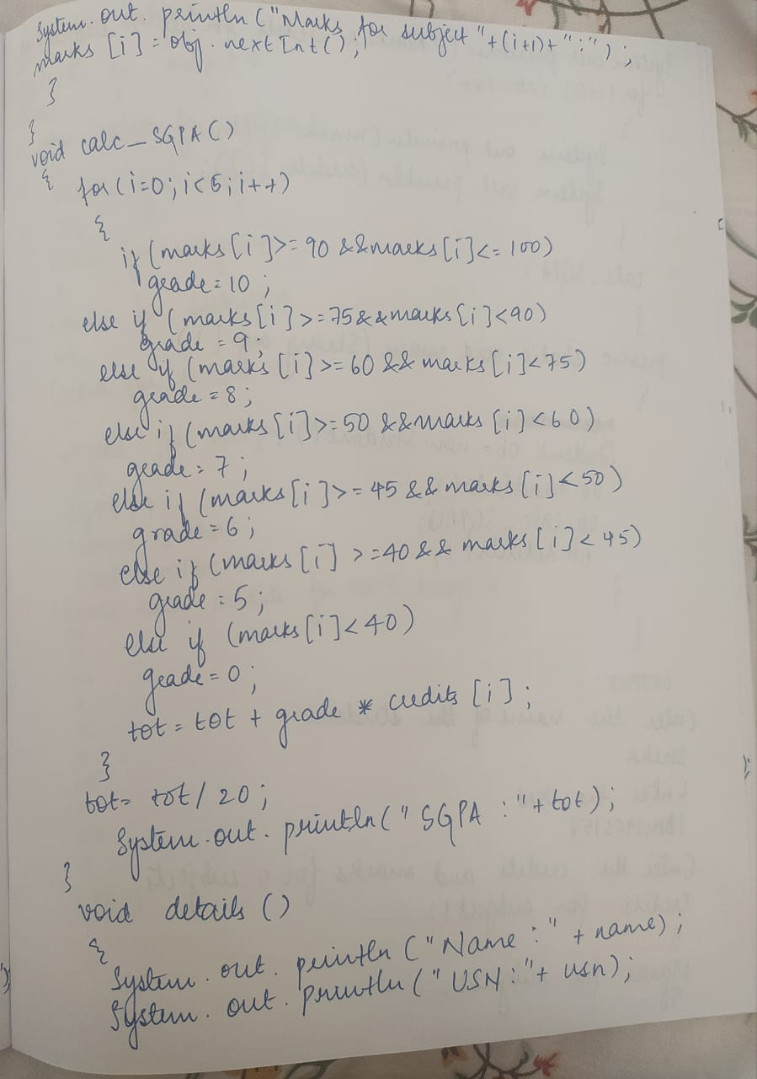

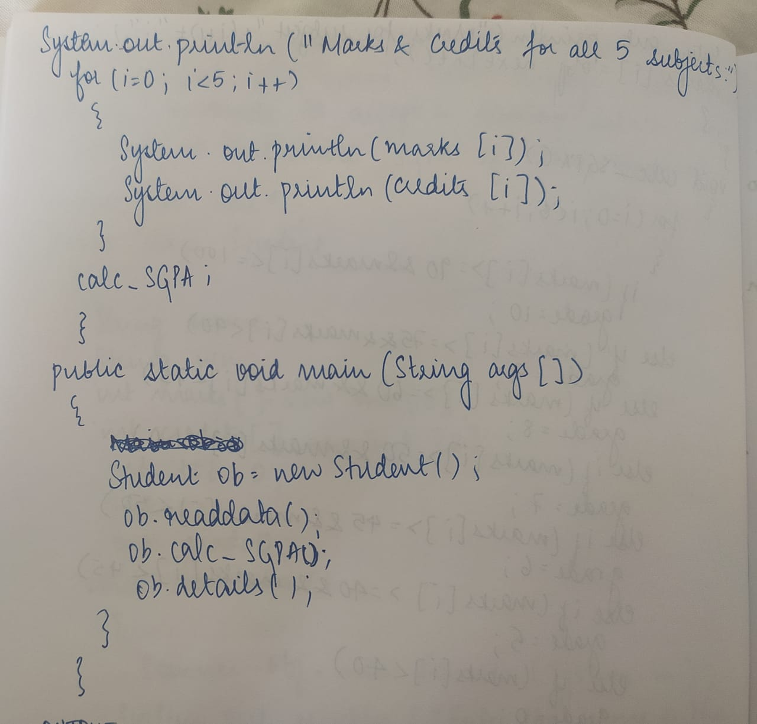

import java.util.*;

public class Main

{

String name;

String usn;

int marks[]=new int[5];

int credits[]=new int[5];

int tot=0;

int i;

int grade=0;

void read_data()

{

Scanner obj=new Scanner(System.in);

System.out.println("Enter the name of the students");

name=obj.next();

System.out.println("Enter the USN");

usn=obj.next();

System.out.println("Enter the credits and marks for 5 subjects");

for(i=0;i<5;i++)

{

System.out.println("Credits for subject"+(i+1)+":");

credits[i]=obj.nextInt();

System.out.println("Marks for subject"+(i+1)+": ");

marks[i]=obj.nextInt();

}

}

void calc_SGPA()

{

for(i=0;i<5;i++)

{

if(marks[i]>=90&&marks[i]<=100)

grade=10;

else if(marks[i]>=75&&marks[i]<90)

grade=9;

else if(marks[i]>=60&&marks[i]<75)

grade=8;

else if(marks[i]>=50&&marks[i]<60)

grade=7;

else if(marks[i]>=45&&marks[i]<50)

grade=6;

else if(marks[i]>=40&&marks[i]<45)

grade=5;

else if(marks[i]<40)

grade=0;

tot=tot+grade*credits[i];

}

tot=tot/20;

System.out.println("SGPA:"+tot);

}

void details()

{

System.out.println("Name:"+name);

System.out.println("USN:"+usn);

System.out.println("Marks and Credits for all 5 subjects:");

for(i=0;i<5;i++)

{

System.out.println(marks[i]);

System.out.println(credits[i]);

}

calc_SGPA();

}

public static void main(String args[])

{

Main ob=new Main();

ob.read_data();

ob.calc_SGPA();

ob.details();

}

}

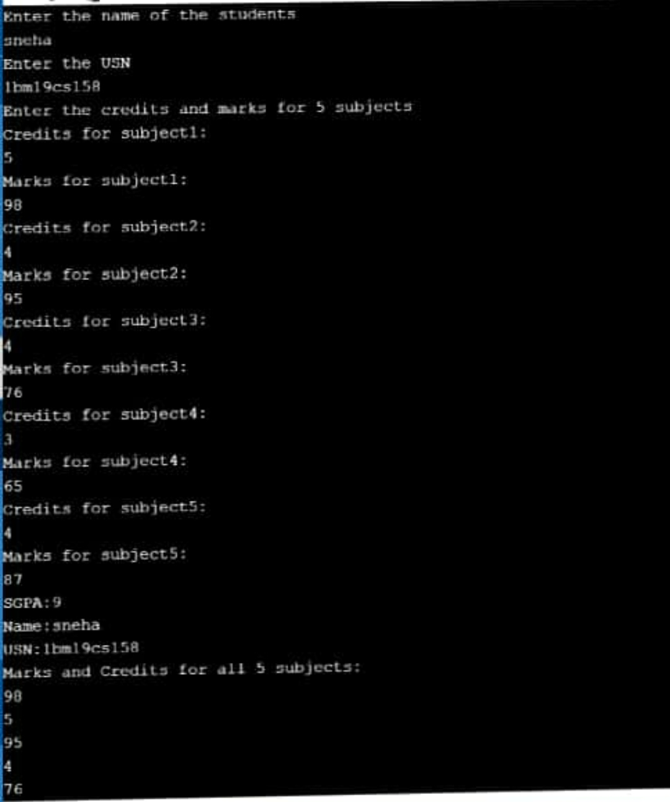

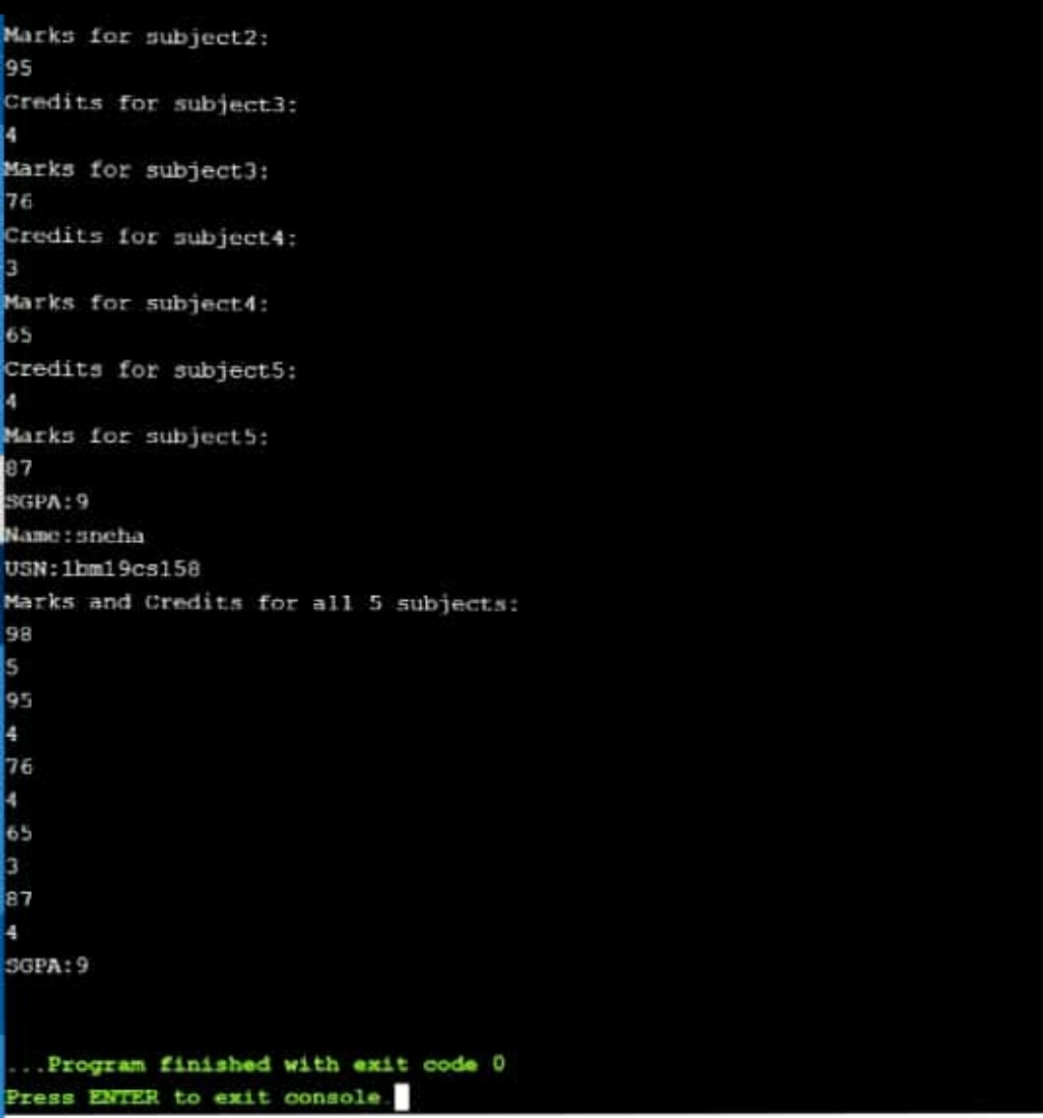

**LAB PROGRAM 3:**

**Create a class Book which contains four members: name, author, price,**

**num_pages. Include a constructor to set the values for the members. Include**

**methods to set and get the details of the objects. Include a toString( ) method**

**that could display the complete details of the book. Develop a Java program to**

**create n book objects.**

**Info about toString( ) method:**

**class Test**

**{**

**int a=10;**

**public String toString() // when an object is printed this method is automatically called**

**{ return(&quot;a=&quot;+a);} //return statement with String is required**

**}**

**class TestMain**

**{**

**public static void main (String ss[])**

**{**

**Test t1=new Test ();**

**System.out.println (t1);**

**//t1 - First example where an object is printed directly**

**//calls toString method with the object given as the invoking object**

**}**

**}**

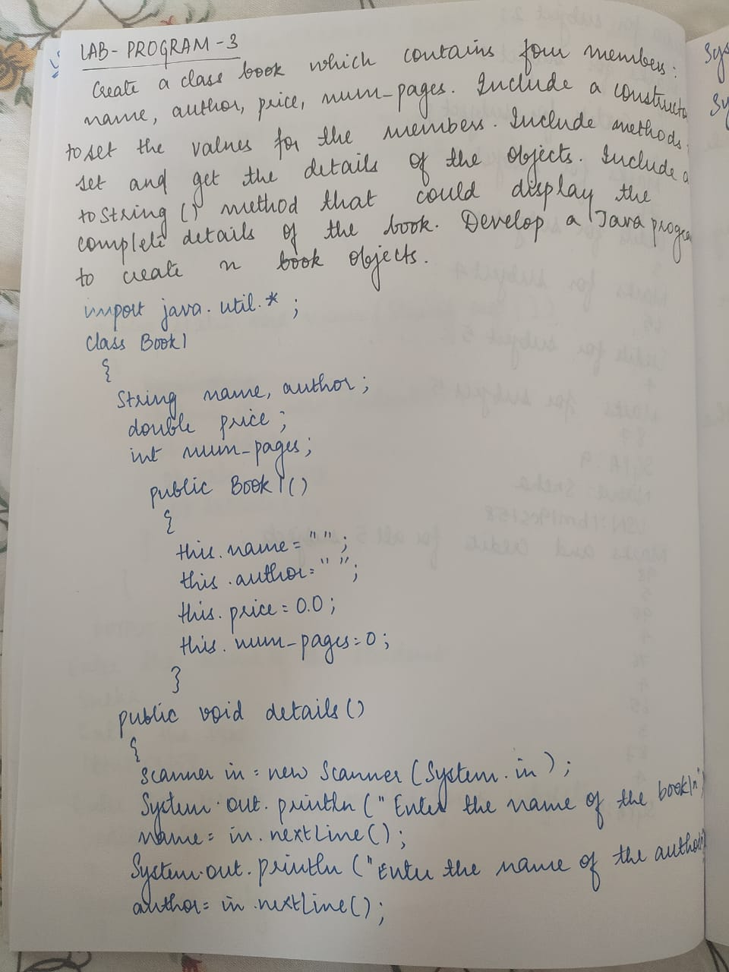

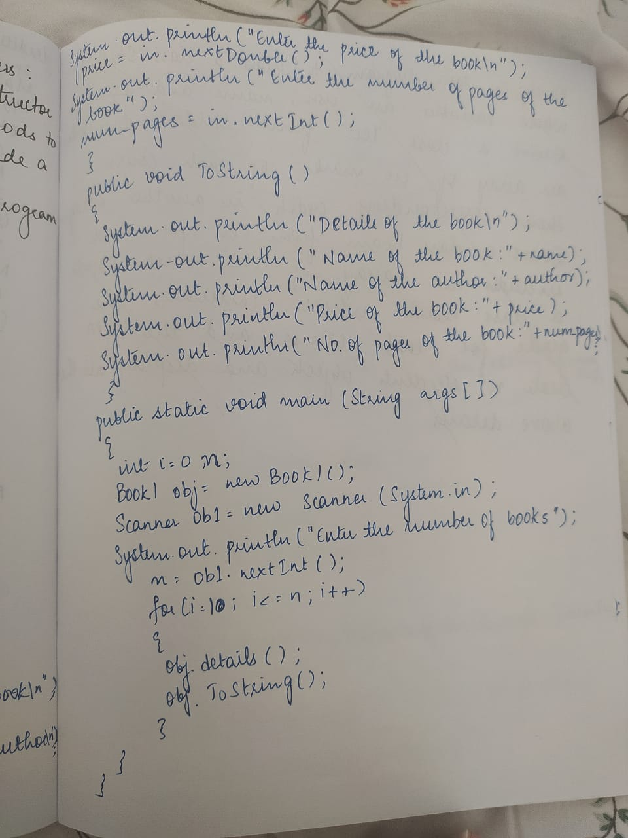

import java.util.*;

public class Main

{

String name;

String author;

double price;

int num_pages;

public Book(String n, String a, double d,int np)

{

name = n;

author = a;

price = d;

num_pages = np;

}

public String getName()

{

return name;

}

public String getAuthor()

{

return author;

}

public double getPrice()

{

return price;

}

public int getNumPages()

{

return num_pages;

}

public void setName(String n)

{

name = n;

}

public void setAuthor(String a)

{

author = a;

}

public void setPrice(double p)

{

price = p;

}

public void setNumPages(int np)

{

num_pages = np;

}

public String toString()

{

return getName() + " " + getAuthor() + " " + getPrice() + " " + getNumPages();

}

public static void main (String ss[])

{

Scanner xx = new Scanner(System.in);

System.out.println("Enter number of objects:");

int n = xx.nextInt();

Book b[]=new Book[n];

for(int i=0;i<n;i++)

{

b[i]= new Book ();

System.out.println("Enter the title of the book"+(i+1));

b[i].getName();

System.out.println("Enter the name of the author for book"+(i+1));

b[i].getAuthor();

System.out.println("Enter the price of the book"+(i+1));

b[i].getPrice();

System.out.println("Enter the number of pages of the book"+(i+1));

b[i].getNumPages();

System.out.println("Book details:");

for(i=0;i<n;i++)

{

System.out.println(b[i].toString());

}

}

}}

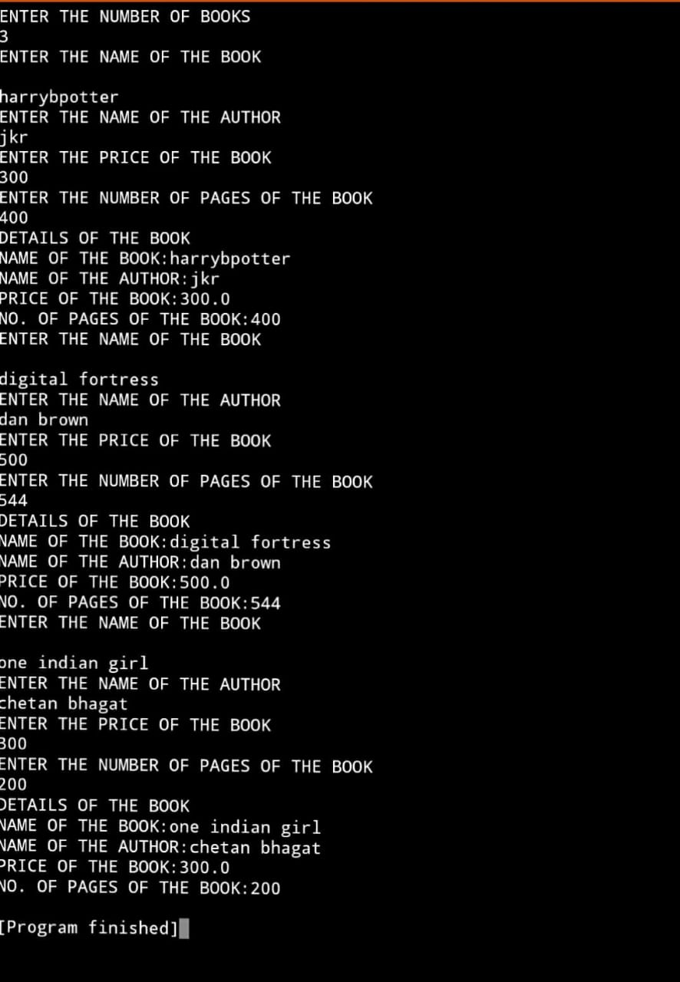

**LAB PROGRAM 4:**

**Develop a Java program to create an abstract class named Shape that contains two integers and an empty method named printArea( ). Provide three classes named Rectangle, Triangle and Circle such that each one of the classes extends the class Shape. Each one of the classes contain only the method printArea( ) that prints the area of the given shape.**

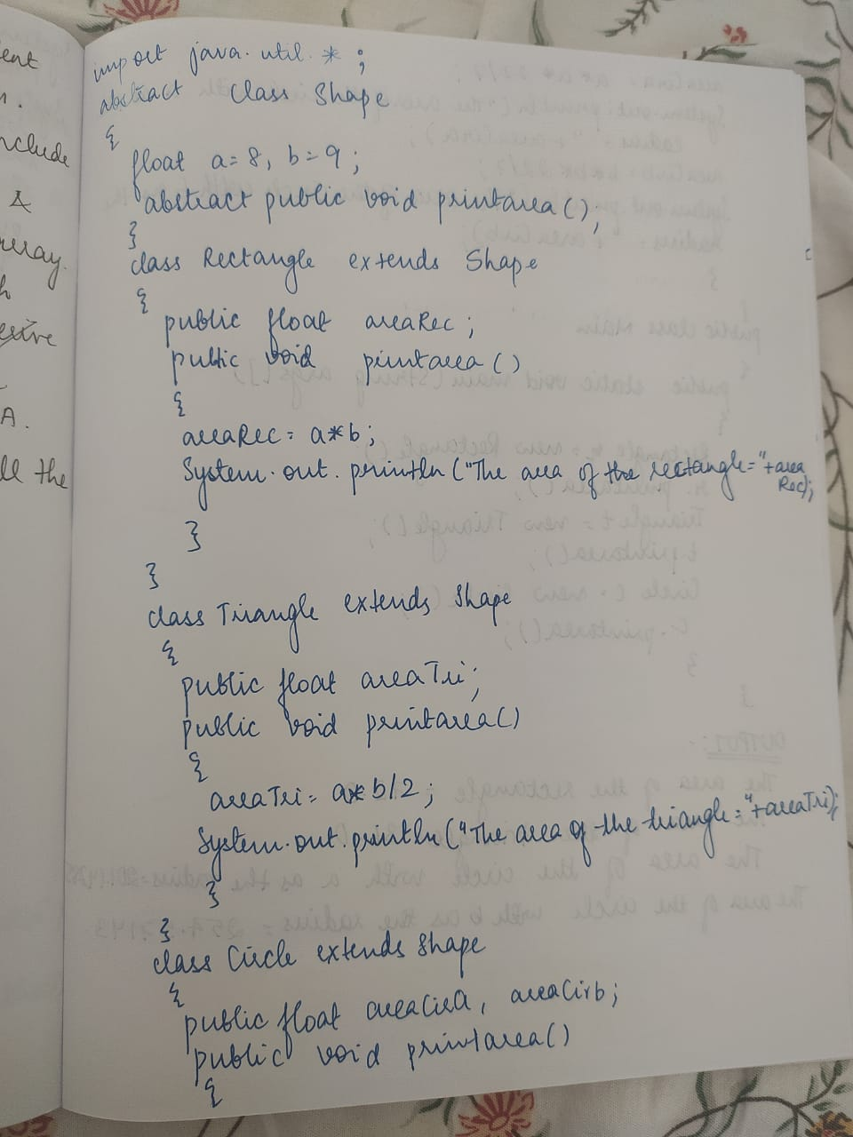

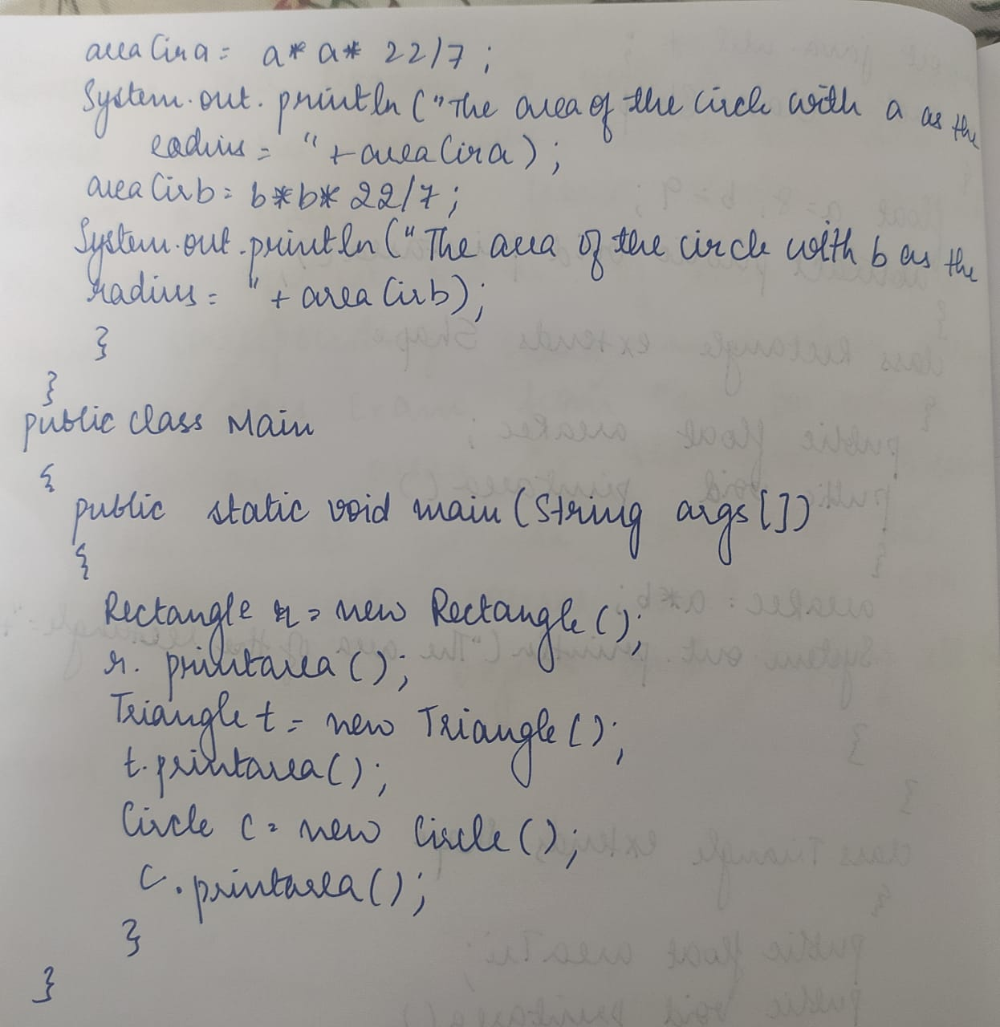

import java.util.*;

abstract class Shape

{

float a=8,b=9;

abstract public void printarea();

}

class Rectangle extends Shape

{

public float areaRec;

public void printarea()

{

areaRec=a*b;

System.out.println("The area of the rectangle="+areaRec);

}

}

class Triangle extends Shape

{

public float areaTri;

public void printarea()

{

areaTri=a*b/2;

System.out.println("The area of the triangle="+areaTri);

}

}

class Circle extends Shape

{

public float areaCir;

public void printarea()

{

areaCir=a*a*22/7;

System.out.println("The area of the circle="+areaCir);

}

}

public class Main

{

public static void main(String args[])

{

Rectangle r=new Rectangle();

r.printarea();

Triangle t= new Triangle();

t.printarea();

Circle c= new Circle();

c.printarea();

}

}

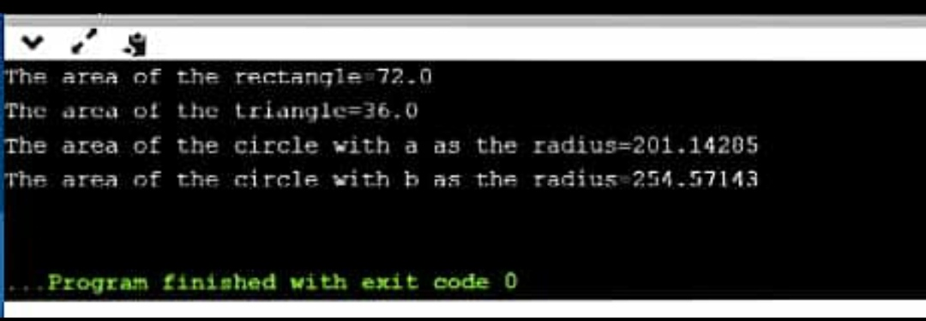

**LAB PROGRAM 5:**

**Develop a Java program to create a class Bank that maintains two kinds of account for its customers, one called savings account and the other current account. The savings account provides compound interest and withdrawal facilities but no cheque book facility. The current account provides cheque book facility but no interest. Current account holders should also maintain a minimum balance and if the balance falls below this level, a service charge is imposed. Create a class Account that stores customer name, account number and type of account. From this derive the classes Curr-acct and Sav-acct to make them more specific to their requirements. Include the necessary methods in order to achieve the following tasks: • Accept deposit from customer and update the balance. • Display the balance. • Compute and deposit interest • Permit withdrawal and update the balance • Check for the minimum balance, impose penalty if necessary and update the balance.**

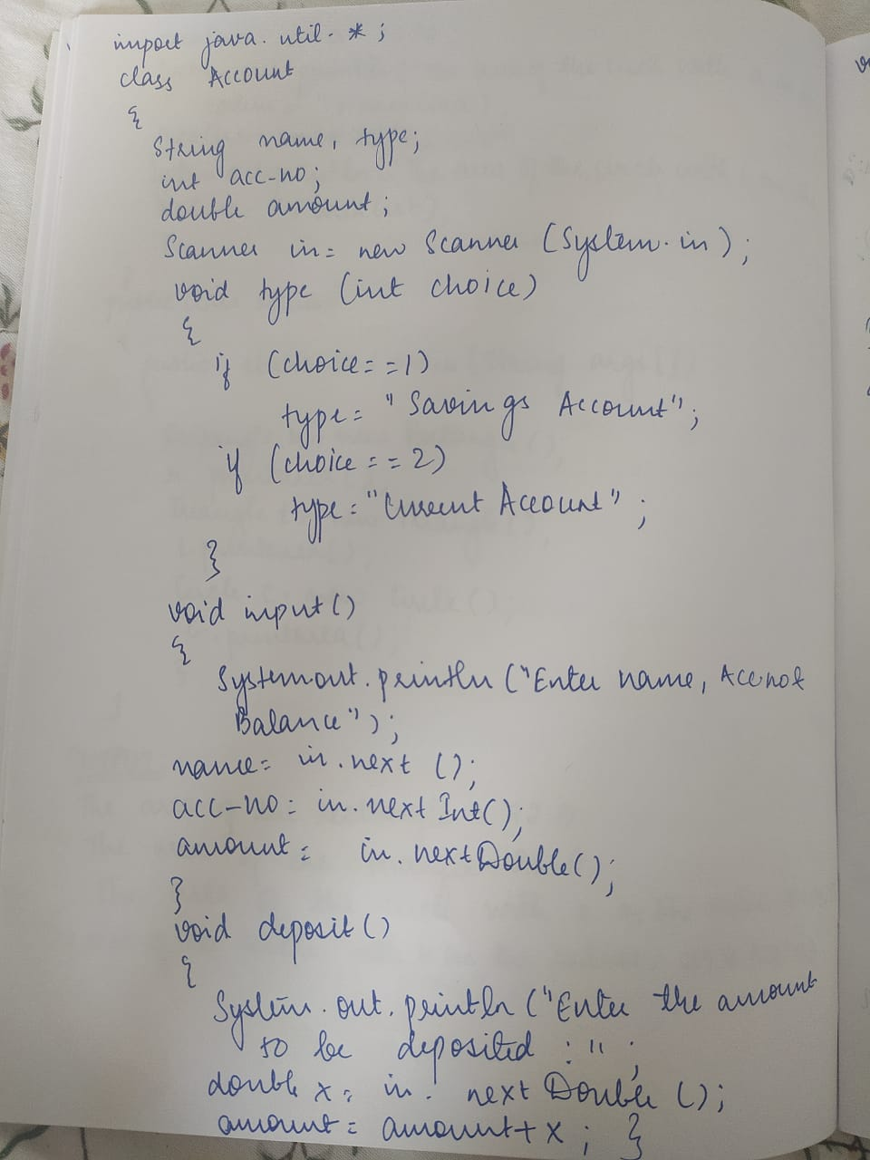

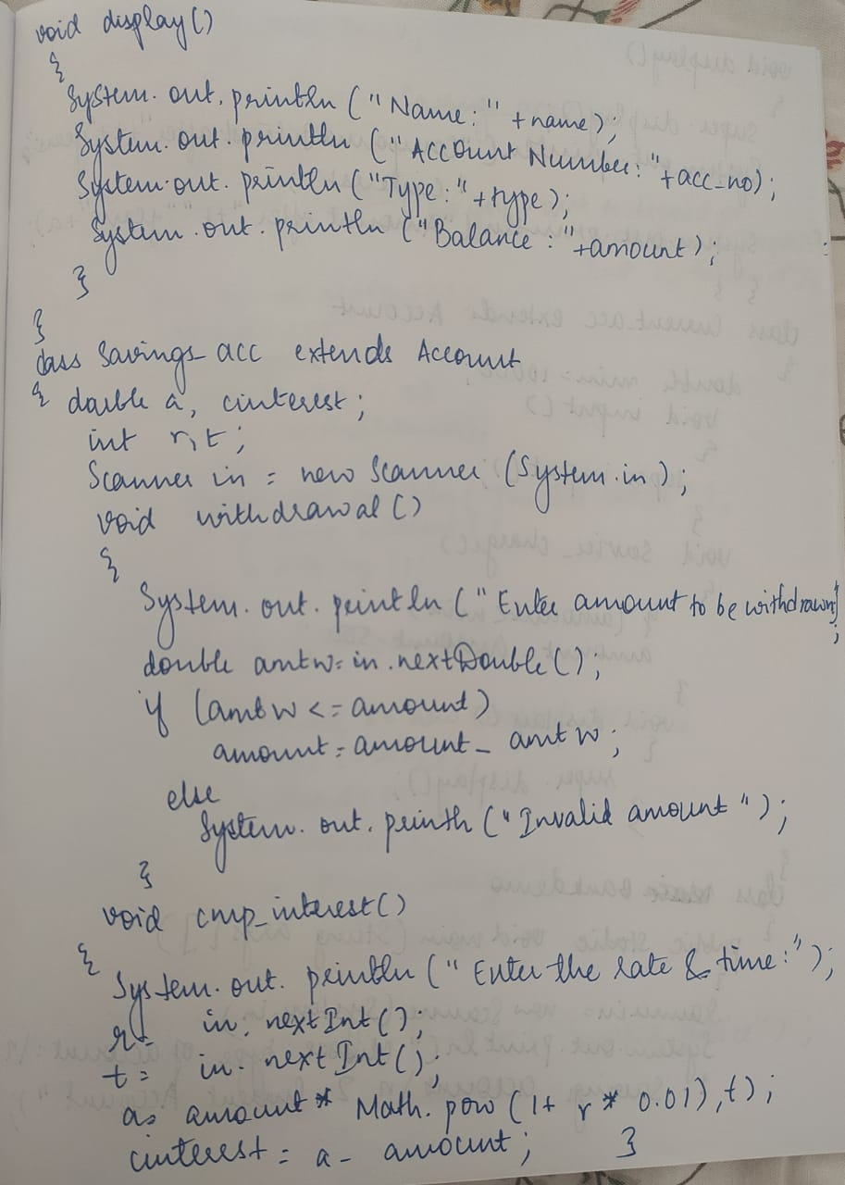

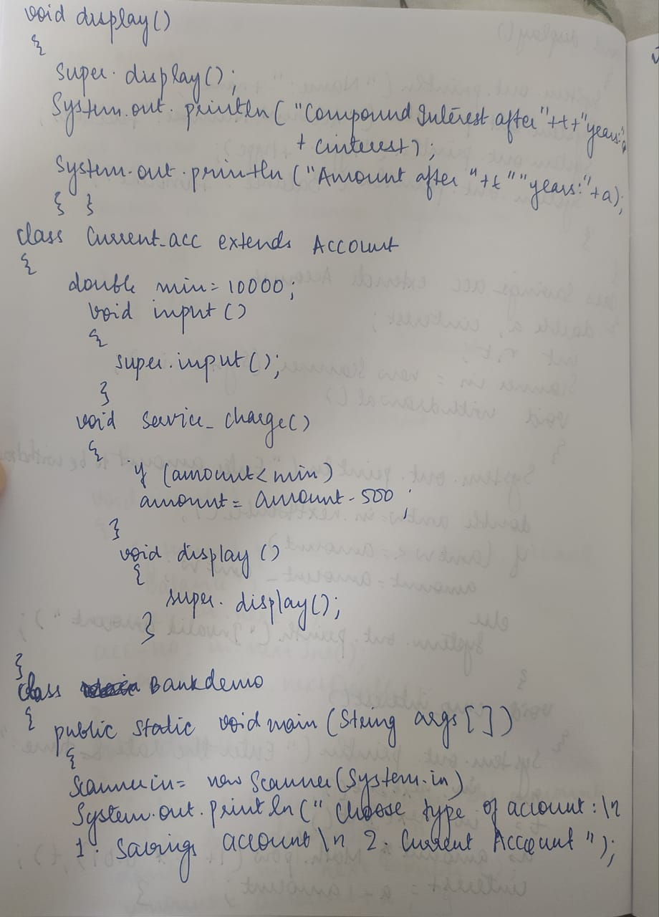

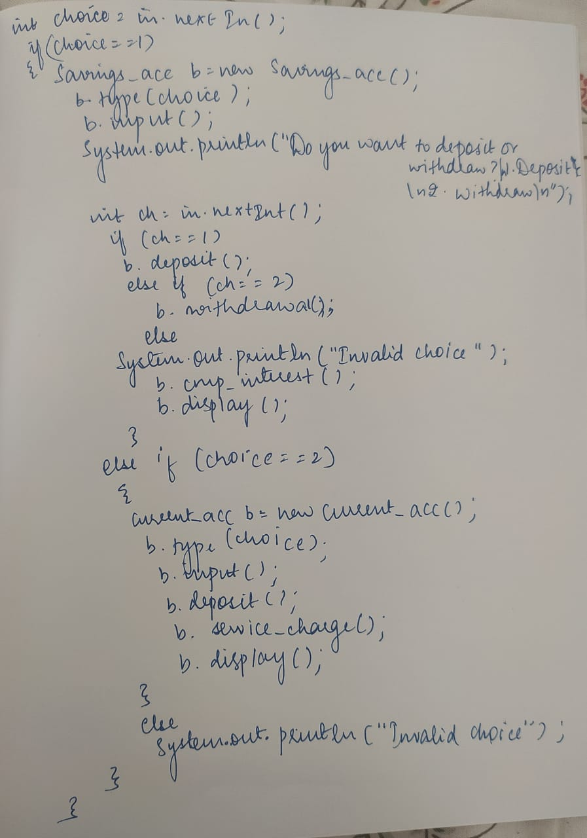

import java.util.*;

class Account

{

String name,type;

int acc_no;

double amount;

Scanner in=new Scanner(System.in);

void type(int choice)

{

if(choice==1)

type="Savings Account";

if(choice==2)

type="Current Account";

}

void input()

{

System.out.println("Enter the Name,Account number and Balance:");

name=in.next();

acc_no=in.nextInt();

amount=in.nextDouble();

}

void deposit()

{

System.out.println("Enter the amount to be deposited:");

double x=in.nextDouble();

amount=amount+x;

}

void display()

{

System.out.println("Name:"+name);

System.out.println("Account number:"+acc_no);

System.out.println("Type:"+type);

System.out.println("balance:"+amount);

}

}

class Savings_acc extends Account

{

double a,cinterest;

int r,t;

Scanner in=new Scanner(System.in);

void withdrawal()

{

System.out.println("Enter amount to be withdrawn:");

double amtw=in.nextDouble();

if(amtw<=amount)

amount=amount-amtw;

else

System.out.println("Invalid amount");

}

void cmp_interest()

{

System.out.println("Enter the rate and time:");

r=in.nextInt();

t=in.nextInt();

a=amount* Math.pow(1 + (r *0.01),t);

cinterest= a - amount;

}

void display()

{

super.display();

System.out.println("Compound Interest after " + t + " years: "+cinterest);

System.out.println("Amount after " + t + " years: "+a);

}

}

class Current_acc extends Account

{

double min=10000;

void input()

{

super.input();

}

void service_charge()

{

if(amount<min)

amount=amount-500;

}

void display()

{

super.display();

}

}

class bankdemo

{

public static void main(String args[])

{

Scanner in=new Scanner(System.in);

System.out.println("Choose type of account.");

System.out.println("1.Savings account.");

System.out.println("2.Current account.");

int choice=in.nextInt();

if(choice==1)

{

Savings_acc b=new Savings_acc();

b.type(choice);

b.input();

System.out.println("Do you want to deposit or withdraw?\n1.Deposit.\n2.Withdraw\n");

int ch=in.nextInt();

if(ch==1)

b.deposit();

else if(ch==2)

b.withdrawal();

else

System.out.println("Invalid choice");

b.cmp_interest();

b.display();

}

else if(choice==2)

{

Current_acc b=new Current_acc();

b.type(choice);

b.input();

b.deposit();

b.service_charge();

b.display();

}

else

System.out.println("Invalid choice");

}

}

